Supplementary Information
Anthrax-MLNet: A Hybrid Machine Learning Approach with Multi-Step Feature Selection for Identifying Candidate Biomarkers and Drug Targets in Anthrax
This document provides the complete numerical results, extended analyses, and reproducibility information supporting the main manuscript. Each section states what was evaluated, how, what was found, and what the finding means, so that it can be read independently of the main text. Analyses that did not improve performance are included rather than omitted; where an analysis cannot be scored, that is reported in place of a number.
Supplementary tables are numbered S1–S12 and supplementary figures S1–S6, in order of appearance.

Table S1: The 12-gene candidate biomarker panel. Cohen's d, p-values, and false discovery rates refer to the combined discovery cohort (n = 11); per-cohort log fold-changes are reported separately for GSE14390 and GSE12131. Because the two series were deposited at different processing stages, only the direction of effect is compared between them. WNT6 is also a member of the PPI-derived hub set.
Gene | Set | Cohens  _d  _combi  ned | P_  Combi  ned | FDR_  Combi  ned | logFC_  GSE14  390 | P_GSE  14390 | Direc  tion_  GSE1  4390 | logFC_  GSE12  131 | P_GSE  12131 | Direc  tion_  GSE1  2131 | Direc  tion_  concor  dant
LOC101  928461 | Common DEG | 2.251 | 0.004 | 0.03 | 1.991 | 0.003 | Up in exposed | 0.85 | 0.619 | Up in exposed | Yes
LINC00  485 | Common DEG | -2.188 | 0.005 | 0.03 | -2.01 | <0.001 | Down in exposed | -0.769 | 0.631 | Down in exposed | Yes
LOC1005  06530 | Common DEG | -2.115 | 0.015 | 0.036 | -2.016 | <0.001 | Down in exposed | -0.699 | 0.658 | Down in exposed | Yes
WNT6 | Common DEG + hub | 2.068 | 0.011 | 0.036 | 1.326 | 0.003 | Up in exposed | 0.05 | 0.871 | Up in exposed | Yes
RNF128 | Common DEG | 2.056 | 0.012 | 0.036 | 1.975 | <0.001 | Up in exposed | 0.718 | 0.642 | Up in exposed | Yes
VWC2 | Common DEG | -1.922 | 0.027 | 0.053 | -1.989 | <0.001 | Down in exposed | -0.571 | 0.73 | Down in exposed | Yes
GULP1 | Common DEG | 1.526 | 0.032 | 0.055 | 0.323 | 0.394 | Up in exposed | 1.054 | 0.002 | Up in exposed | Yes
CNTN4 | Common DEG | 1.007 | 0.122 | 0.183 | 1.137 | 0.045 | Up in exposed | -0.228 | 0.734 | Down in exposed | No
TTC6 | Common DEG | 0.955 | 0.188 | 0.226 | 0.906 | 0.113 | Up in exposed | -0.039 | 0.967 | Down in exposed | No
GATAD  2A | Common DEG | -0.935 | 0.143 | 0.191 | -0.396 | 0.403 | Down in exposed | -0.72 | 0.392 | Down in exposed | Yes
IL20RA | Common DEG | -0.91 | 0.217 | 0.237 | -1.216 | 0.194 | Down in exposed | 0.369 | 0.346 | Up in exposed | No
ACSS1 | Common DEG | -0.376 | 0.54 | 0.54 | -0.4 | 0.195 | Down in exposed | 0.325 | 0.283 | Up in exposed | No

Table S2: Composition and processing of the two discovery cohorts. The log2 column records whether the deposited values required transformation before standardisation.
Cohort | Samples | Exposed | Control | Probe_sets | log2_transformed
GSE14390 | 7 | 3 | 4 | 42904 | FALSE
GSE12131 | 4 | 2 | 2 | 42904 | TRUE

Table S3: Sample annotation for the combined discovery cohort. Sample indices correspond to those used in Table S5.
Sample_index | Dataset | Group
1 | GSE14390 | Control
2 | GSE14390 | Control
3 | GSE14390 | Control
4 | GSE14390 | Control
5 | GSE14390 | Exposed
6 | GSE14390 | Exposed
7 | GSE14390 | Exposed
8 | GSE12131 | Control
9 | GSE12131 | Control
10 | GSE12131 | Exposed
11 | GSE12131 | Exposed

Table S4: Effect size, significance, and achieved statistical power for the sixteen genes assessed, comprising the twelve overlapping DEGs and the five PPI-derived hub genes, with WNT6 belonging to both. The required sample size is that needed to detect the observed effect at 80% power (α = 0.05, two-sided). No gene met either quality-control criterion.
Gene | Set | Mean_  exposed | Mean_  control | Cohens  _d | Effect  _size | Direction | t_test  _P | t_test  _FDR | Wilco  xon_P | Wilcoxon  _FDR | Achie  ved  _power | Adequ  ate  _power | N_per  _group  _for_  80pct
LOC101  928461 | Common DEG | 0.852 | -0.71 | 2.25 | large | Up in exposed | 0.004 | 0.039 | 0.03 | 0.081 | 0.91 | Yes | 5
LINC00  485 | Common DEG | -0.843 | 0.702 | -2.188 | large | Down in exposed | 0.005 | 0.039 | 0.009 | 0.046 | 0.894 | Yes | 5
WNT6 | Common DEG + hub | 0.465 | -0.387 | 2.068 | large | Up in exposed | 0.011 | 0.047 | 0.009 | 0.046 | 0.859 | Yes | 5
RNF128 | Common DEG | 0.821 | -0.684 | 2.056 | large | Up in exposed | 0.012 | 0.047 | 0.017 | 0.069 | 0.855 | Yes | 5
LOC100  506530 | Common DEG | -0.831 | 0.692 | -2.115 | large | Down in exposed | 0.015 | 0.048 | 0.009 | 0.046 | 0.874 | Yes | 5
VWC2 | Common DEG | -0.796 | 0.663 | -1.922 | large | Down in exposed | 0.026 | 0.071 | 0.082 | 0.188 | 0.806 | Yes | 6
GULP1 | Common DEG | 0.322 | -0.268 | 1.526 | large | Up in exposed | 0.032 | 0.073 | 0.03 | 0.081 | 0.613 | No | 8
CNTN4 | Common DEG | 0.344 | -0.287 | 1.007 | large | Up in exposed | 0.122 | 0.244 | 0.126 | 0.251 | 0.318 | No | 17
GATAD  2A | Common DEG | -0.28 | 0.233 | -0.935 | large | Down in exposed | 0.143 | 0.254 | 0.329 | 0.439 | 0.282 | No | 19
TTC6 | Common DEG | 0.303 | -0.252 | 0.955 | large | Up in exposed | 0.188 | 0.301 | 0.329 | 0.439 | 0.292 | No | 19
IL20RA | Common DEG | -0.343 | 0.286 | -0.91 | large | Down in exposed | 0.217 | 0.316 | 0.177 | 0.316 | 0.27 | No | 20
FZD9 | Hub | 0.404 | -0.337 | 0.722 | medium | Up in exposed | 0.298 | 0.398 | 0.247 | 0.395 | 0.187 | No | 32
FZD3 | Hub | 0.097 | -0.081 | 0.522 | medium | Up in exposed | 0.432 | 0.531 | 0.429 | 0.527 | 0.121 | No | 59
FZD6 | Hub | 0.243 | -0.203 | 0.414 | small | Up in exposed | 0.519 | 0.576 | 0.662 | 0.757 | 0.094 | No | 93
ACSS1 | Common DEG | -0.072 | 0.06 | -0.376 | small | Down in exposed | 0.54 | 0.576 | 0.792 | 0.845 | 0.086 | No | 113
DKK4 | Hub | -0.08 | 0.067 | -0.134 | negligible | Down in exposed | 0.83 | 0.83 | 0.931 | 0.931 | 0.054 | No | 879

Table S5: Leave-one-out cross-validated predictions for each sample under both panels. Probabilities are those produced by the model refitted without that sample; calls are made at the Youden point of the cross-validated predictions.
Sample  _index | Dataset | Group | LOO_  Probability  _12gene | LOO_  Probability  _hub | LOO_call  _12gene | LOO_call  _hub | Correct_  12gene | Correct  _hub
1 | GSE14390 | Control | 0.2577 | 0.4804 | Control | Exposed | Yes | No
2 | GSE14390 | Control | 0.2368 | 0.5625 | Control | Exposed | Yes | No
3 | GSE14390 | Control | 0.1825 | 0.3624 | Control | Control | Yes | Yes
4 | GSE14390 | Control | 0.2843 | 0.3242 | Control | Control | Yes | Yes
5 | GSE14390 | Exposed | 0.8235 | 0.4795 | Exposed | Exposed | Yes | Yes
6 | GSE14390 | Exposed | 0.7909 | 0.496 | Exposed | Exposed | Yes | Yes
7 | GSE14390 | Exposed | 0.8114 | 0.667 | Exposed | Exposed | Yes | Yes
8 | GSE12131 | Control | 0.5308 | 0.5175 | Exposed | Exposed | No | No
9 | GSE12131 | Control | 0.28 | 0.448 | Control | Control | Yes | Yes
10 | GSE12131 | Exposed | 0.3578 | 0.4835 | Exposed | Exposed | Yes | Yes
11 | GSE12131 | Exposed | 0.684 | 0.4802 | Exposed | Exposed | Yes | Yes

Table S6: Discrimination by individual hub genes. AUC was computed using standardised expression directly as the classifier score, without fitting any model, and is therefore free of resubstitution bias; confidence intervals are from stratified bootstrap resampling over 2000 replicates. FDR values are corrected across the five genes.
Gene | AUC | CI_low | CI_high | Cohens_d | Direction | t_test_P | t_test_FDR | Wilcoxon_P
WNT6 | 0.967 | 0.8 | 1 | 2.068 | Higher in exposed | 0.011 | 0.056 | 0.009
FZD9 | 0.733 | 0.4 | 1 | 0.722 | Higher in exposed | 0.298 | 0.649 | 0.247
FZD3 | 0.667 | 0.267 | 1 | 0.522 | Higher in exposed | 0.432 | 0.649 | 0.429
FZD6 | 0.6 | 0.2 | 1 | 0.414 | Higher in exposed | 0.519 | 0.649 | 0.662
DKK4 | 0.533 | 0.167 | 0.867 | -0.134 | Lower in exposed | 0.83 | 0.83 | 0.931

Table S7: Approximately unbiased (AU) and bootstrap probability (BP) support for each internal node of the sample dendrogram, under both harmonisation pipelines. The root node is omitted, since it is supported trivially. Nodes with AU ≥ 0.95 are marked as supported.
Pipeline | Node | AU | BP | SE_AU | P_value | Supported_AU95
P1_filtered_data | 1 | 0.732 | 0.664 | 0.0258 | 0.269 | No
P1_filtered_data | 2 | 0.958 | 0.786 | 0.0075 | 0.042 | Yes
P1_filtered_data | 3 | 0.962 | 0.564 | 0.0064 | 0.038 | Yes
P1_filtered_data | 4 | 0.919 | 0.692 | 0.0119 | 0.081 | No
P1_filtered_data | 5 | 0.856 | 0.543 | 0.0175 | 0.144 | No
P1_filtered_data | 6 | 0.798 | 0.475 | 0.0217 | 0.202 | No
P1_filtered_data | 7 | 0.768 | 0.474 | 0.0234 | 0.232 | No
P1_filtered_data | 8 | 0.912 | 0.575 | 0.0124 | 0.088 | No
P1_filtered_data | 9 | 0.893 | 0.499 | 0.0143 | 0.107 | No
P2_datasets_csv | 1 | 0.932 | 0.79 | 0.011 | 0.068 | No
P2_datasets_csv | 2 | 0.982 | 0.851 | 0.0041 | 0.018 | Yes
P2_datasets_csv | 3 | 0.916 | 0.545 | 0.012 | 0.085 | No
P2_datasets_csv | 4 | 0.894 | 0.64 | 0.0143 | 0.106 | No
P2_datasets_csv | 5 | 0.959 | 0.765 | 0.0073 | 0.041 | Yes
P2_datasets_csv | 6 | 0.934 | 0.548 | 0.0099 | 0.066 | No
P2_datasets_csv | 7 | 0.795 | 0.441 | 0.0221 | 0.205 | No
P2_datasets_csv | 8 | 0.766 | 0.532 | 0.0234 | 0.234 | No
P2_datasets_csv | 9 | 0.686 | 0.368 | 0.0279 | 0.314 | No

Table S8: Two-cluster membership from the bootstrap dendrogram, with each sample's cohort of origin and infection status. Agreement with phenotype was 0.82; agreement with cohort of origin was 0.55.
Sample | Cluster | Dataset | Group
GSM305784 | 1 | GSE12131 | Control
GSM305785 | 2 | GSE12131 | Control
GSM305786 | 2 | GSE12131 | Anthrax
GSM305787 | 1 | GSE12131 | Anthrax
GSM359332 | 2 | GSE14390 | Control
GSM359753 | 2 | GSE14390 | Control
GSM359754 | 2 | GSE14390 | Control
GSM359755 | 2 | GSE14390 | Control
GSM359758 | 1 | GSE14390 | Anthrax
GSM359759 | 1 | GSE14390 | Anthrax
GSM359760 | 1 | GSE14390 | Anthrax

Table S9: Per-node AU values under the two harmonisation pipelines, with their difference and whether each node's support status was consistent between them.
Node | AU_pipeline1 | AU_pipeline2 | Delta_AU | Supported_P1 | Supported_P2 | Agreement
1 | 0.7315 | 0.9324 | 0.2009 | No | No | consistent
2 | 0.9576 | 0.9816 | 0.024 | Yes | Yes | consistent
3 | 0.9623 | 0.9155 | 0.0468 | Yes | No | FLIPPED
4 | 0.9191 | 0.8939 | 0.0252 | No | No | consistent
5 | 0.8559 | 0.9586 | 0.1027 | No | Yes | FLIPPED
6 | 0.7979 | 0.9344 | 0.1365 | No | No | consistent
7 | 0.7683 | 0.7949 | 0.0266 | No | No | consistent
8 | 0.9117 | 0.7663 | 0.1454 | No | No | consistent
9 | 0.893 | 0.6858 | 0.2072 | No | No | consistent
10 | 1 | 1 | 0 | Yes | Yes | consistent

Table S10: A comprehensive analysis was performed to assess the significance of the association between P-values and frequently occurring genes in the GO (BP, CC, and MF), KEGG, WikiPathways, Reactome, BioCarta, BioPlanet, and DsigBD databases
Database | Term | P-value | Adjusted P-value | Genes
GO_Biological_Process | Regulation of Apoptotic Process (GO:0042981) | 0.003868054783571444 | 0.09982545942863763 | AHI1;DKKL1;PTMA;IGF1R
 | Positive Regulation of Protein Localization to Chromosome, Telomeric Region (GO:1904816) | 0.00474139160939957 | 0.09982545942863763 | PML
 | Cytochrome Metabolic Process (GO:1903604) | 0.00474139160939957 | 0.09982545942863763 | CYP2U1
 | Regulation of Protein Localization to Chromosome, Telomeric Region (GO:1904814) | 0.00474139160939957 | 0.09982545942863763 | PML
 | Regulation of Translational Initiation in Response to Stress (GO:0043558) | 0.005687115738983334 | 0.09982545942863763 | PML
 | Notch Receptor Processing (GO:0007220) | 0.00663198906678106 | 0.09982545942863763 | GALNT11
 | Dendritic Spine Maintenance (GO:0097062) | 0.00663198906678106 | 0.09982545942863763 | IGF1R
 | Negative Regulation of Vasoconstriction (GO:0045906) | 0.00663198906678106 | 0.09982545942863763 | DOCK4
 | Positive Regulation of Vascular Associated Smooth Muscle Cell Migration (GO:1904754) | 0.0075760122063041925 | 0.09982545942863763 | DOCK4
 | Protein O-linked Glycosylation via Threonine (GO:0018243) | 0.008519185800335128 | 0.09982545942863763 | GALNT11
GO_Cellular_Component | Transferase Complex, Transferring Phosphorus-Containing Groups (GO:0061695) | 0.0075760122063041925 | 0.11622188003447768 | IGF1R
 | Primary Lysosome (GO:0005766) | 0.010402987018789436 | 0.11622188003447768 | OLFM4
 | Protein Kinase Complex (GO:1902911) | 0.020703445636816073 | 0.11622188003447768 | IGF1R
 | Pigment Granule (GO:0048770) | 0.02256531142960272 | 0.11622188003447768 | SYTL2
 | P Granule (GO:0043186) | 0.02349498640716487 | 0.11622188003447768 | TDRD9
 | Exocytic Vesicle (GO:0070382) | 0.027205316711375317 | 0.11622188003447768 | SYTL2
 | Secretory Vesicle (GO:0099503) | 0.02905547000861942 | 0.11622188003447768 | SYTL2
 | Melanosome (GO:0042470) | 0.02905547000861942 | 0.11622188003447768 | SYTL2
 | Nucleolus (GO:0005730) | 0.03892481118124631 | 0.1280979236750563 | DOCK4;PML;IGF1R
 | Nuclear Lumen (GO:0031981) | 0.04003060114845509 | 0.1280979236750563 | DOCK4;PML;IGF1R
GO_Molecular_Function | Riboflavin Transmembrane Transporter Activity (GO:0032217) | 0.00474139160939957 | 0.09611585348385629 | SLC22A14
 | Semaphorin Receptor Activity (GO:0017154) | 0.009461510512395743 | 0.09611585348385629 | PLXNA2
 | Neurexin Family Protein Binding (GO:0042043) | 0.009461510512395743 | 0.09611585348385629 | SYTL2
 | SUMO Binding (GO:0032183) | 0.013222334171232074 | 0.09611585348385629 | PML
 | Insulin-Like Growth Factor Binding (GO:0005520) | 0.014160424747060764 | 0.09611585348385629 | IGF1R
 | Receptor Antagonist Activity (GO:0048019) | 0.01603407239546545 | 0.09611585348385629 | DKKL1
 | Ribosomal Small Subunit Binding (GO:0043024) | 0.01790434673262116 | 0.09611585348385629 | EIF4B
 | Insulin Receptor Binding (GO:0005158) | 0.01790434673262116 | 0.09611585348385629 | IGF1R
 | Steroid Hydroxylase Activity (GO:0008395) | 0.021634798076404317 | 0.09611585348385629 | CYP2U1
 | Notch Binding (GO:0005112) | 0.021634798076404317 | 0.09611585348385629 | GALNT11
KEGG | Pathways in cancer | 1.6007464465940872e-16 | 1.3446270151390334e-14 | HDAC1;STAT2;HGF;ERBB2;STAT3;MDM2;JAK2;PML;IGF1R;JAK1
KEGG | PI3K-Akt signaling pathway | 5.83056039916967e-09 | 2.4488353676512615e-07 | HGF;ERBB2;MDM2;JAK2;IGF1R;JAK1
KEGG | Epstein-Barr virus infection | 2.418823027510253e-08 | 5.468676060302919e-07 | HDAC1;STAT2;STAT3;MDM2;JAK1
KEGG | Proteoglycans in cancer | 2.6041314572871046e-08 | 5.468676060302919e-07 | HGF;ERBB2;STAT3;MDM2;IGF1R
KEGG | Signaling pathways regulating pluripotency of stem cells | 5.089005289720745e-07 | 8.549528886730852e-06 | STAT3;JAK2;IGF1R;JAK1
KEGG | Necroptosis | 7.78155412717457e-07 | 8.804835910119095e-06 | STAT2;STAT3;JAK2;JAK1
KEGG | JAK-STAT signaling pathway | 8.385558009637234e-07 | 8.804835910119095e-06 | STAT2;STAT3;JAK2;JAK1
KEGG | Hepatitis B | 8.385558009637234e-07 | 8.804835910119095e-06 | STAT2;STAT3;JAK2;JAK1
KEGG | Influenza A | 1.0653381927458568e-06 | 9.943156465627995e-06 | STAT2;JAK2;PML;JAK1
KEGG | Transcriptional misregulation in cancer | 1.6522764653746114e-06 | 1.2881310503869374e-05 | HDAC1;MDM2;PML;IGF1R
WiKipathway | Cancer Pathways WP5434 | 1.0038898366229864e-16 | 1.8070017059213757e-14 | HDAC1;STAT2;HGF;ERBB2;STAT3;MDM2;JAK2;PML;IGF1R;JAK1
WiKipathway | EGFR Tyrosine Kinase Inhibitor Resistance WP4806 | 9.478968873949188e-13 | 8.531071986554269e-11 | HGF;ERBB2;STAT3;JAK2;IGF1R;JAK1
WiKipathway | IL6 Signaling WP364 | 3.851630075325531e-09 | 2.310978045195319e-07 | HDAC1;STAT3;JAK2;JAK1
WiKipathway | Thyroid Stimulating Hormone TSH Signaling WP2032 | 1.3194101796692674e-08 | 5.937345808511703e-07 | STAT3;JAK2;IGF1R;JAK1
WiKipathway | IL10 Anti Inflammatory Signaling WP4495 | 1.975325674652796e-08 | 7.111172428750067e-07 | STAT2;STAT3;JAK1
WiKipathway | ncRNAs Involved In STAT3 Signaling In Hepatocellular Carcinoma WP4337 | 2.5672603330014545e-08 | 7.701780999004364e-07 | STAT3;JAK2;JAK1
WiKipathway | Leptin Signaling WP2034 | 3.012233823650474e-08 | 7.745744117958362e-07 | ERBB2;STAT3;JAK2;JAK1
WiKipathway | Prolactin Signaling WP2037 | 3.5645724228129814e-08 | 8.020287951329207e-07 | ERBB2;STAT3;JAK2;JAK1
WiKipathway | Immune Response To Tuberculosis WP4197 | 1.379143686230442e-07 | 2.758287372460884e-06 | STAT2;JAK2;JAK1
WiKipathway | Androgen Receptor Network In Prostate Cancer WP2263 | 1.7090436968772706e-07 | 2.992161265242917e-06 | HGF;STAT3;MDM2;JAK1
Reactome | Disease | 1.850219543728829e-10 | 5.08810374525428e-08 | HDAC1;STAT2;HGF;ERBB2;STAT3;MDM2;JAK2;PML;IGF1R;JAK1
Reactome | Interleukin-20 Family Signaling | 4.68480811645484e-10 | 6.441611160125407e-08 | STAT2;STAT3;JAK2;JAK1
Reactome | Interleukin-27 Signaling | 1.4818761302081364e-08 | 1.0187898395180938e-06 | STAT3;JAK2;JAK1
Reactome | Interleukin-6 Signaling | 1.4818761302081364e-08 | 1.0187898395180938e-06 | STAT3;JAK2;JAK1
Reactome | Interleukin-35 Signalling | 1.975325674652796e-08 | 1.086429121059038e-06 | STAT3;JAK2;JAK1
Reactome | Diseases of Signal Transduction by Growth Factor Receptors and Second Messengers | 2.474084645630725e-08 | 1.133955462580749e-06 | HDAC1;HGF;ERBB2;STAT3;MDM2;JAK2
Reactome | Signaling by Receptor Tyrosine Kinases | 6.905612889545374e-08 | 2.7129193494642533e-06 | HDAC1;HGF;ERBB2;STAT3;JAK2;IGF1R
Reactome | Signal Transduction | 9.673158364802686e-08 | 3.3251481879009234e-06 | HDAC1;HGF;ERBB2;STAT3;MDM2;JAK2;PML;IGF1R;JAK1
Reactome | Interferon Signaling | 1.234792290092498e-07 | 3.4564678398350887e-06 | STAT2;STAT3;JAK2;PML;JAK1
Reactome | PIP3 Activates AKT Signaling | 1.2568973963036686e-07 | 3.4564678398350887e-06 | HDAC1;HGF;ERBB2;MDM2;PML
BioCarta | Role of ERBB2 in Signal Transduction and Oncology Homo sapiens h her2Pathway | 6.413108912119444e-10 | 3.0141611886961383e-08 | ERBB2;STAT3;JAK2;JAK1
BioCarta | Stat3 Signaling Pathway Homo sapiens h stat3Pathway | 5.033265573129969e-09 | 1.1828174096855429e-07 | STAT3;JAK2;JAK1
BioCarta | IL 6 signaling pathway Homo sapiens h il6Pathway | 2.5672603330014545e-08 | 4.022041188368946e-07 | STAT3;JAK2;JAK1
BioCarta | IFN gamma signaling pathway Homo sapiens h ifngPathway | 3.3713141681840526e-06 | 3.961294147616262e-05 | JAK2;JAK1
BioCarta | IFN alpha signaling pathway Homo sapiens h ifnaPathway | 8.084763760961904e-06 | 7.59967793530419e-05 | STAT2;JAK1
BioCarta | IL22 Soluble Receptor Signaling Pathway Homo sapiens h il22bppathway | 1.234519196297719e-05 | 9.6704003709988e-05 | STAT3;JAK1
BioCarta | Sumoylation by RanBP2 Regulates Transcriptional Repression Homo sapiens h ranbp2Pathway | 2.04094503025842e-05 | 0.00013703488060306536 | HDAC1;MDM2
BioCarta | EGF Signaling Pathway Homo sapiens h egfPathway | 4.254530034649759e-05 | 0.0002499536395356733 | STAT3;JAK1
BioCarta | TPO Signaling Pathway Homo sapiens h TPOPathway | 6.173695322587491e-05 | 0.00032240408906845783 | STAT3;JAK2
BioCarta | PDGF Signaling Pathway Homo sapiens h pdgfPathway | 7.265883245949173e-05 | 0.0003414965125596111 | STAT3;JAK1
BioPlanet | Pathways in cancer | 1.9517938047337523e-13 | 4.606233379171654e-11 | HDAC1;HGF;ERBB2;STAT3;MDM2;PML;IGF1R;JAK1
BioPlanet | Interleukin-27-mediated signaling events | 4.68480811645484e-10 | 5.528073577416713e-08 | STAT2;STAT3;JAK2;JAK1
BioPlanet | Immune system signaling by interferons, interleukins, prolactin, and growth hormones | 1.4298395540601624e-09 | 1.1248071158606613e-07 | STAT2;HGF;STAT3;JAK2;PML;JAK1
BioPlanet | Leptin signaling pathway | 1.6217188052366822e-08 | 9.568140950896422e-07 | ERBB2;STAT3;JAK2;JAK1
BioPlanet | Thyroid-stimulating hormone signaling pathway | 2.237032739234791e-08 | 1.0097890643139055e-06 | STAT3;JAK2;IGF1R;JAK1
BioPlanet | Interleukin-22 soluble receptor signaling pathway | 2.5672603330014545e-08 | 1.0097890643139055e-06 | STAT3;JAK2;JAK1
BioPlanet | Interleukin-6 signaling pathway | 3.012233823650474e-08 | 1.015553117687874e-06 | HDAC1;STAT3;JAK2;JAK1
BioPlanet | Prolactin activation of MAPK signaling | 3.7644908603965495e-08 | 1.1105248038169822e-06 | ERBB2;STAT3;JAK2;JAK1
BioPlanet | Immune system | 7.932256198009344e-08 | 2.049574689362683e-06 | STAT2;HGF;STAT3;MDM2;JAK2;PML;JAK1
BioPlanet | STAT3 pathway | 8.684638514248656e-08 | 2.049574689362683e-06 | STAT3;JAK2;JAK1
DSigBD | curcumin CTD 00000663 | 9.624731064478704e-10 | 1.0510206322410747e-06 | HDAC1;HGF;ERBB2;STAT3;MDM2;JAK2;IGF1R
DSigBD | Arsenenous acid CTD 00000922 | 1.125007154544032e-08 | 6.142539063810416e-06 | HDAC1;HGF;ERBB2;STAT3;MDM2;JAK2;PML;JAK1
DSigBD | Capsaicin CTD 00005570 | 2.6683516299472512e-08 | 9.712799933007994e-06 | ERBB2;STAT3;MDM2;IGF1R;JAK1
DSigBD | Vorinostat BOSS | 5.6805663671864834e-08 | 1.0055255092706986e-05 | HDAC1;ERBB2;STAT3;MDM2
DSigBD | 172889-27-9 BOSS | 5.963163884052429e-08 | 1.0055255092706986e-05 | ERBB2;STAT3;MDM2;JAK2
DSigBD | NVP-TAE684 CTD 00004657 | 6.097651861537575e-08 | 1.0055255092706986e-05 | HGF;ERBB2;STAT3
DSigBD | resveratrol CTD 00002483 | 6.445676341478837e-08 | 1.0055255092706986e-05 | HDAC1;HGF;ERBB2;STAT3;MDM2;PML;IGF1R;JAK1
DSigBD | Erlotinib BOSS | 1.11263735045227e-07 | 1.5187499833673485e-05 | ERBB2;STAT3;JAK2;IGF1R
DSigBD | podophyllotoxin TTD 00010285 | 2.058149650923037e-07 | 2.497221576453285e-05 | STAT3;MDM2;JAK2
DSigBD | podophyllotoxin CTD 00006577 | 2.929226415749853e-07 | 3.159426968121176e-05 | STAT3;MDM2;JAK2

Table S11. Receptor structures and docking grid parameters used for molecular docking of the anthrax hub proteins.
Gene | Organism | Structure source | Structure ID | Method | Resolution / pLDDT | Chains in receptor file | Grid center (x, y, z)
DKK4 | Homo sapiens | Protein Data Bank | 9X64 | X-ray diffraction | 1.83 Å | A, B | -7.297, -15.973, 2.254
FZD3 | Homo sapiens | Protein Data Bank | 8JHI | Cryo-EM | 3.20 Å | A, B, C, N, R | 121.880, 119.383, 98.337
FZD6 | Homo sapiens | Protein Data Bank | 8JHB | Cryo-EM | 3.30 Å | A, B, C, N, R | 119.359, 122.750, 136.538
FZD9 | Homo sapiens | AlphaFold Protein Structure Database | AF-O00144-F1 | Computational prediction | pLDDT 80.93 | A | -7.085, 6.625, -10.132
WNT6 | Homo sapiens | AlphaFold Protein Structure Database | AF-Q9Y6F9-F1 | Computational prediction | pLDDT 83.01 | A | [to be filled after re-docking]
Structures for DKK4, FZD3, and FZD6 were retrieved from the Protein Data Bank (PDB); structures for FZD9 and WNT6 are AlphaFold-predicted models (global pLDDT shown). The full deposited structure, including all co-crystallized chains, was used as the receptor. Grid centers are in Å and were defined as the geometric center of each receptor in AutoDockTools. All docking runs used a 40 × 40 × 40 Å search box, an exhaustiveness of 8, and an energy range of 4. PDB, Protein Data Bank; pLDDT, predicted local distance difference test.
Table S12: Complete molecular docking results for all protein–ligand pairs screened with AutoDock Vina.
Gene | Compound | PubChem CID | Best binding affinity, mode 1 (kcal/mol) | Number of poses reported
DKK4 | Irinotecan | 60838 | -9.6 | 9
DKK4 | Daunorubicin | 30323 | -8.3 | 9
DKK4 | Celastrol | 122724 | -8.3 | 9
DKK4 | Hesperidin | 10621 | -8.3 | 9
DKK4 | Quercetin | 5280343 | -8 | 9
FZD3 | Irinotecan | 60838 | -9.6 | 9
FZD3 | Daunorubicin | 30323 | -7.8 | 9
FZD3 | Celastrol | 122724 | -8.8 | 9
FZD3 | Hesperidin | 10621 | -8.3 | 9
FZD3 | Quercetin | 5280343 | -8.8 | 9
FZD6 | Irinotecan | 60838 | -11.1 | 9
FZD6 | Daunorubicin | 30323 | -8.3 | 9
FZD6 | Celastrol | 122724 | -8.2 | 9
FZD6 | Hesperidin | 10621 | -8.8 | 9
FZD6 | Quercetin | 5280343 | -9.3 | 9
FZD9 | Irinotecan | 60838 | -8.2 | 9
FZD9 | Daunorubicin | 30323 | -7.6 | 9
FZD9 | Celastrol | 122724 | -8.2 | 9
FZD9 | Hesperidin | 10621 | -8.3 | 9
FZD9 | Quercetin | 5280343 | -7.7 | 9
WNT6 | Irinotecan | 60838 | -10 | 9
WNT6 | Daunorubicin | 30323 | -7.7 | 9
WNT6 | Celastrol | 122724 | -8 | 9
WNT6 | Hesperidin | 10621 | -8.5 | 9
WNT6 | Quercetin | 5280343 | -6.7 | 9
Binding affinity (kcal/mol) is the best-scoring pose (mode 1) reported by AutoDock Vina; more negative values indicate stronger predicted binding. Nine poses were reported per docking run. Compounds are identified by their PubChem compound identifier (CID). All runs used a 40 × 40 × 40 Å search box, an exhaustiveness of 8, and an energy range of 4. CID, compound identifier.

Supplementary Figures:
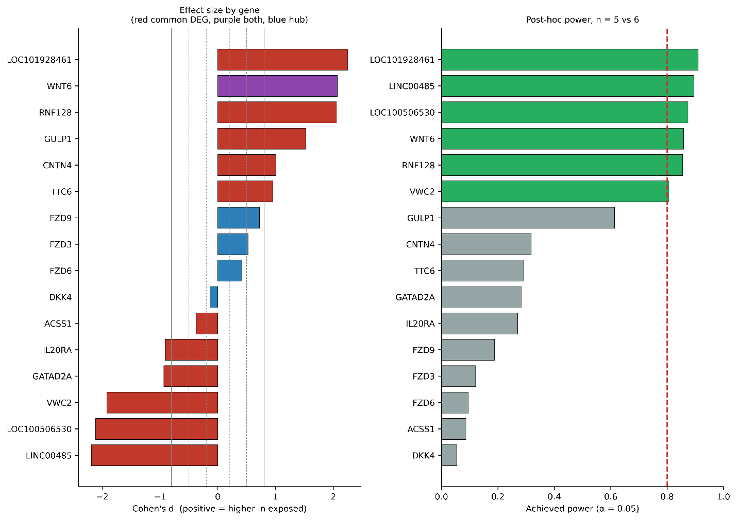
Figure S1: Effect size and achieved statistical power for the sixteen genes assessed. (A) Cohen's d, with reference lines at the conventional small, medium, and large thresholds. (B) Achieved power at a two-sided α of 0.05, with the 0.80 threshold marked.
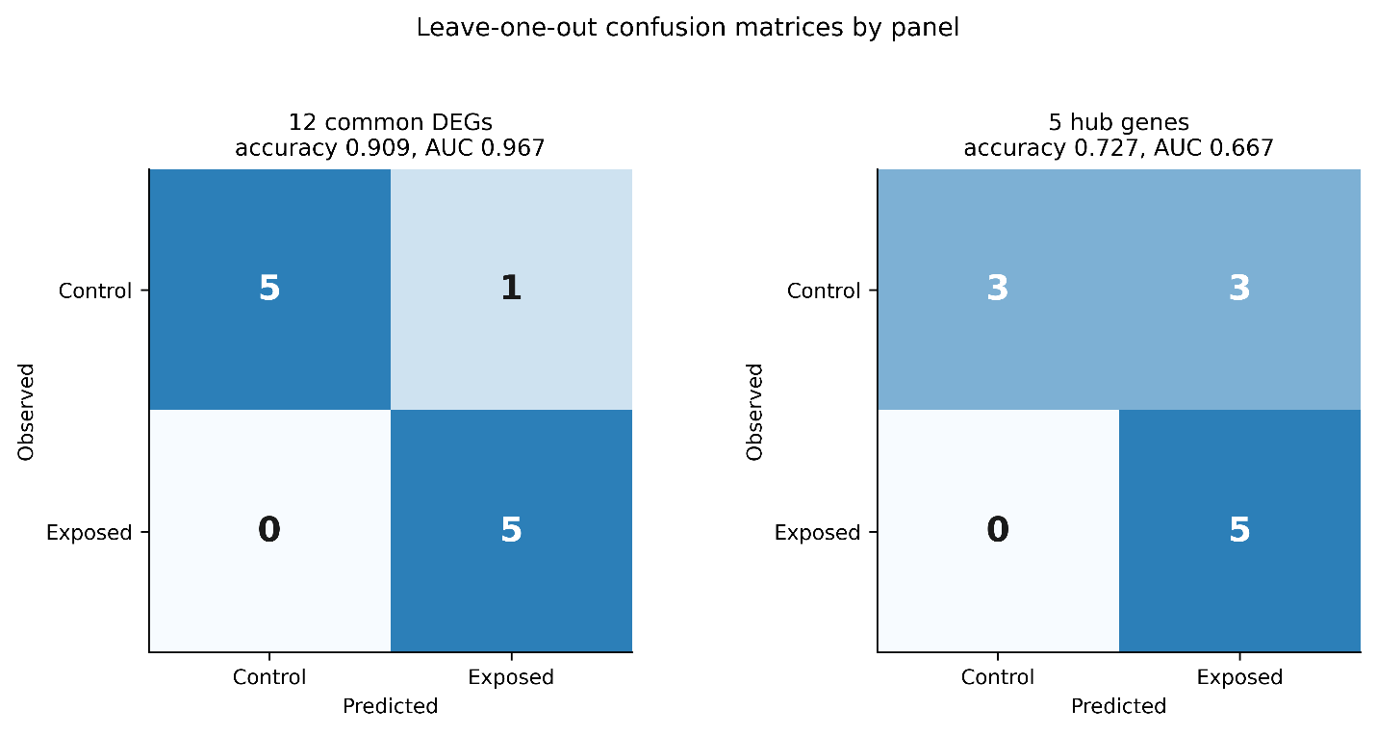
Figure S2: Leave-one-out confusion matrices for both panels in the combined discovery cohort (n = 11; 5 exposed, 6 control). Counts are cross-validated, each sample having been scored by a model refitted without it.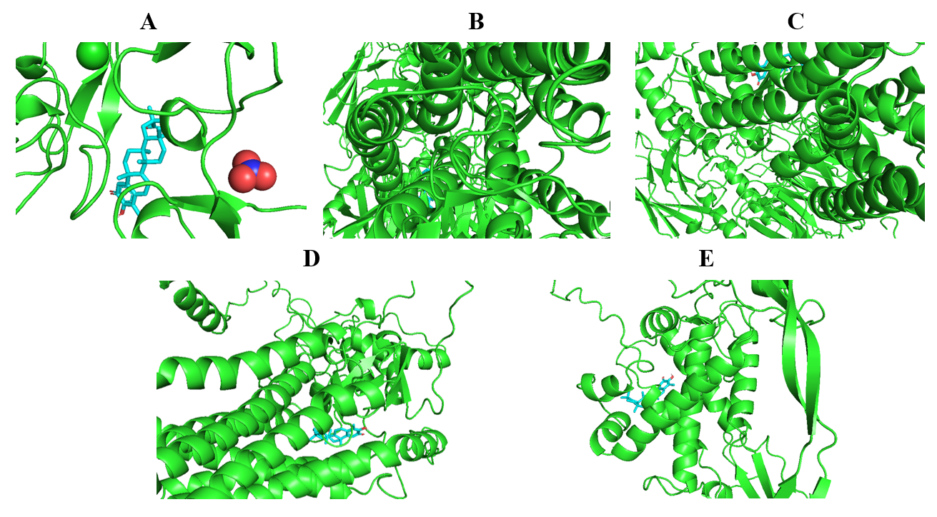
Figure S3: Docked poses of Celastrol in the five anthrax-associated hub proteins: (A) DKK4, (B) FZD3, (C) FZD6, (D) FZD9, (E) WNT6. Receptors are shown as ribbons, and the ligand is shown in stick representation within the predicted binding site. 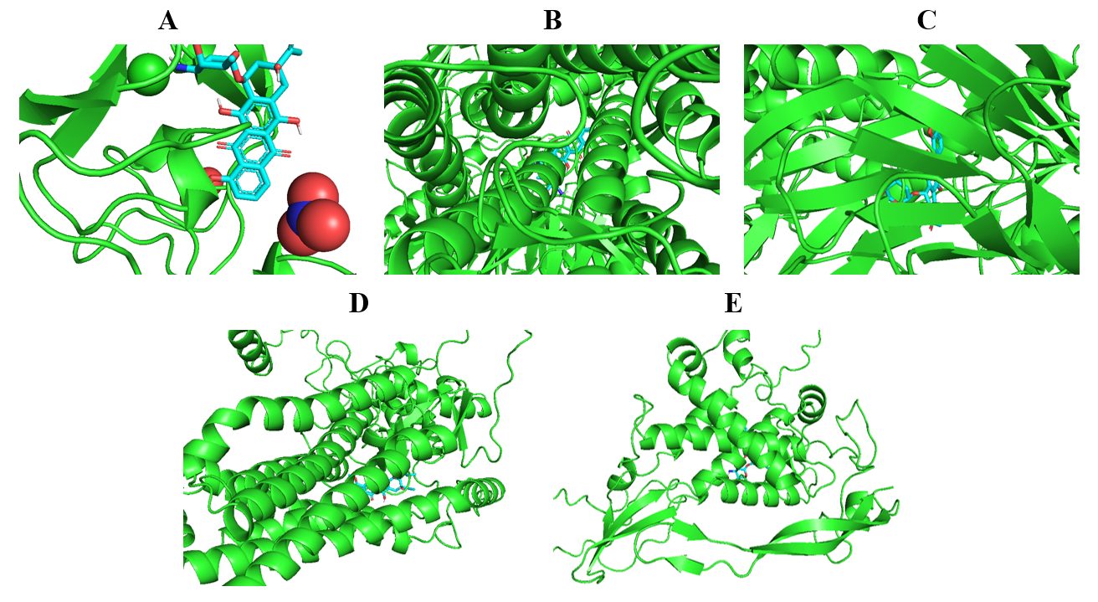
Figure S4: Docked poses of Daunorubicin in the five hub proteins: (A) DKK4, (B) FZD3, (C) FZD6, (D) FZD9, (E) WNT6.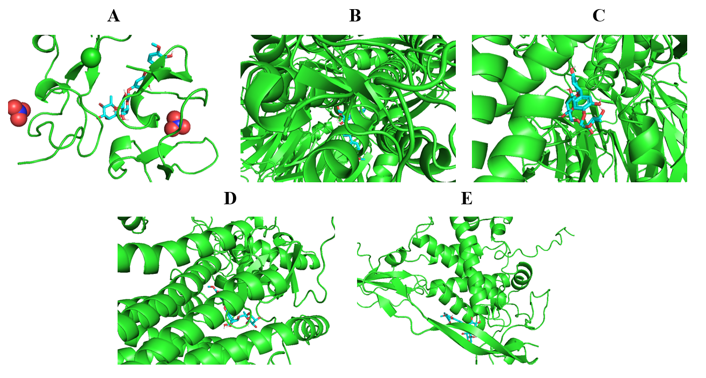
Figure S5: Docked poses of Hesperidin in the five hub proteins: (A) DKK4, (B) FZD3, (C) FZD6, (D) FZD9, (E) WNT6.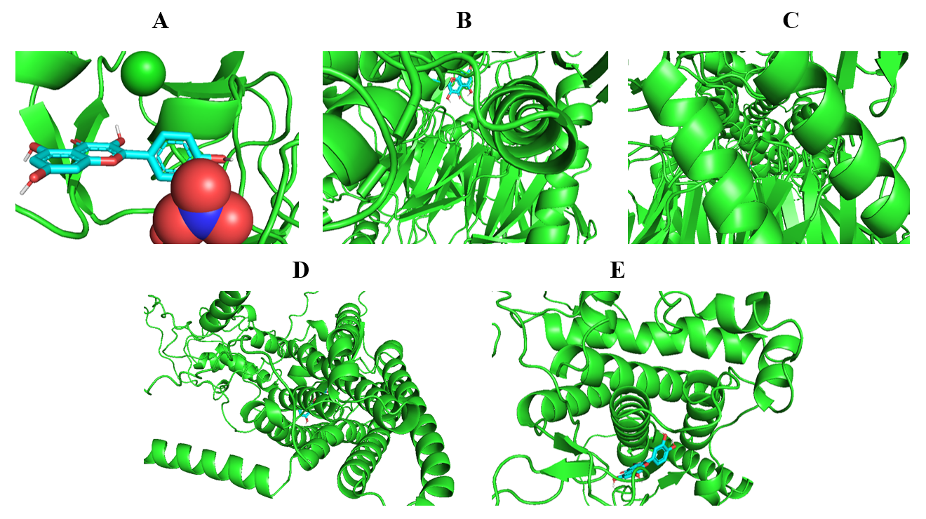
Figure S6: Docked poses of Quercetin in the five hub proteins: (A) DKK4, (B) FZD3, (C) FZD6, (D) FZD9, (E) WNT6.

Reproducibility
Analyses were performed in Python 3.13 (scikit-learn, statsmodels, SciPy, pandas) and R 4.6 (limma, pvclust, data.table, pROC, ggplot2). Networks were constructed in NetworkAnalyst and visualised in Cytoscape v3.10.3 with the CytoHubba plugin; docking used AutoDock Vina 1.2.0 with receptors prepared in AutoDockTools 1.5.7. A fixed random seed was applied throughout. Both series are available from the Gene Expression Omnibus under accessions GSE14390 and GSE12131.

